In factories folder in spec folder: create a ruby file for classes in plural, (e.g. ‘users.rb’)

in users.rb:

FactoryBot.define do
factory :user do
email { define an example with faker }
password { either faker or hardcode }
session_token {securerandom thing}
association :author, factory: :user
end
end

in spec file, in models, within user_spec.rb:
Require rails helper

RSpec.describe -class-, type: :model do
it { should validate_presence_of(:email) }
it {should validate_presence_of(:password_digest)}
it {should validate_length_of(:password).is_at_least(6)}
it {should have_many(:authored_bleats)}

describe ‘uniqueness’ do
before(:each) { create(:user) } - does this before each ‘it’ block
it { should validate_uniqueness_of(:email) }
end

describe “is_password?” do
let(:user) { create(:user) }
context “with a valid password” do
it “should be true” do
expect(user.is_password?(“hunter2)).to be true
end

context “with a valid password” do
it “should be true” do
expect(user.is_password?(“hunter3)).to be false
end
end

end

Google Shoulda-matchers to get the github where the common syntax is

Controllers

require ‘rails_helper’

Rspec.describe BleatsController, type: :controller do

describe “GET #index” do
it renders the bleats index” do
get :index
expect(response).to render_template(:index)
end
end

describe “NEW #new” do
it “displays form to make a bleat”
allow(subject).to receive(:logged_in?).and return(true)
get :new
expect(response).to render_template(:new)
end
end

end

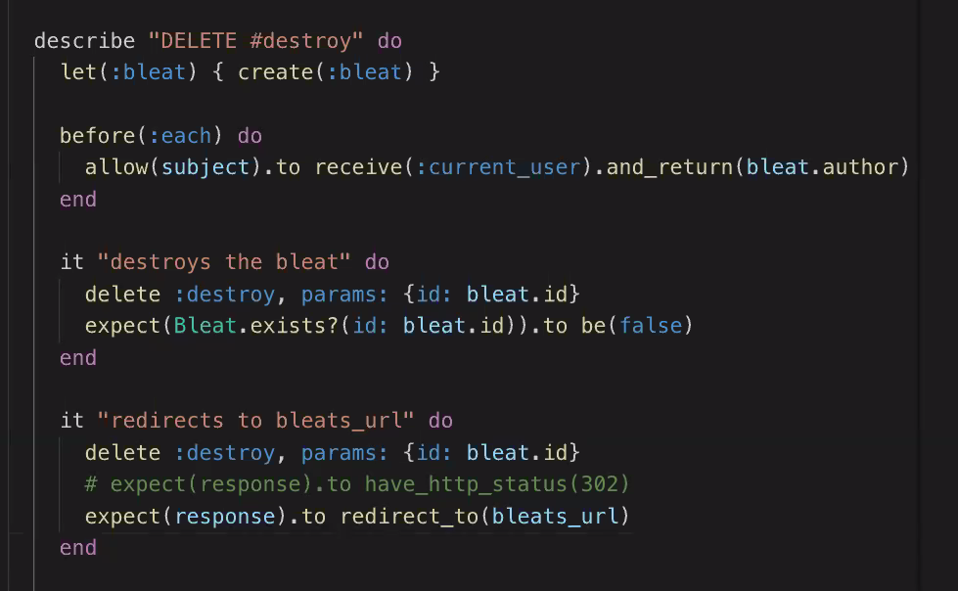
for features
make a new directory called features inside of spec

then inside of features, make a new file called bleats_spec

require ‘rails_helper’ at the top.

Instead of describe, we use ‘feature’, and ‘scenario’ instead of it.

Feature ‘creating a bleat’, type: :feature do
before :each do
user = create(:user)
visit new_session_url
fill_in(“Email”, with: user.email)
fill_in(“Password”, with: “hunter2”)
click_button(“Log In”)
visit new_bleat_url
save_and_open_page
end

scenario “creating a bleat” do
fill_in(“Vody”, with “hello, world”)
click_button(“Create the bleat!”)

expect(page).to have_content(“Hello world!”)
end

end

